WINDOWS XP
LESSON 2

- CLASSIC VIEW VS. DEFAULT VIEW
Right click start and than select properties and chose the view you want.
(For the class computers please use the default view so we will be the same.)
- MY COMPUTER
Click the My Computer icon
FILES STORED ON THIS COMPUTER
Shared documents – rt click and select properties – shows what it contains. Do the same with other files.
HARD DISK DRIVES
Right click on each local disk and select properties –(General tab) this will show the used and free space.
(Tools Tab) this will allow you to check for errors on the drive, Defrag the disk, and back up the disk.
(Hardware Tab) this shows the hardware in this computer, and if it is working.
(Sharing Tab) This controls the sharing of files in a network. Not recommended.(Quota Tab) allows you to limit the size of files that can be put on the disk.
DEVICES WITH REMOVABLE STORAGE
By right clicking and selecting properties you can get similar information as in hard drives.
- CONTROL PANEL
Click on start and select settings/control panel.
In control panel select mouse.
The first tab “Buttons” allows you to make the mouse a left hand moue or a right hand mouse.
The second tab allows you to select the appearance of the mouse pointer.
The third tab gives you pointer options.
The fourth tab allows you to adjust the scrolling speed.
The fifth tab lets you adjust the click speed.

A TYPICAL WINDOW

TITLE

TITLE BAR
MINIMIZE
MAKE WINDOW

EXIT

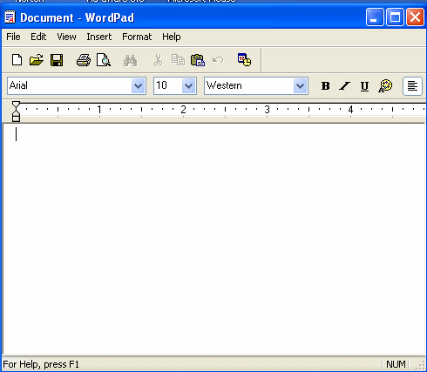
MENU BAR

TOOL BAR

FORMAT BAR
VIEW AREA

