WINDOWS XP

TUESDAY 2:00 PM

LESSON 1
- Fill out form
- a review of topics for semester
- Review ground rules
- Difference between Windows XP and Windows 98
- Difference between windows XP Professional and Home Edition
- Logging on to the XP profile
- Getting information of your home computer
- Difference between right click and left click of mouse
  - Left click starts a program or selects something
  - Right click opens a menu
Next right click the “my Computer” select “properties”
Under the general tab you will see the most important information on your
computer.
OR:
Right click Start- select in order- programs/ accessories/system tools/system information. At this point you can get more information.
- Putting icons on your desk top
  - Right click Start – select programs/ games
  - Right click and hold solitaire and drag to desktop let go and than select copy here. DO NOT SELECT MOVE
  - Grab hold of the icon by right click and hold and drag the icon where you want it on the desktop.
- Taskbar
  - Rt. Click in bare spot in taskbar and select properties. Check the following
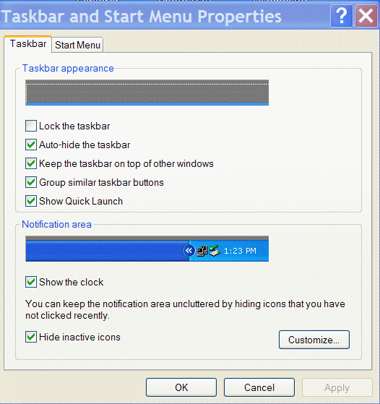.
tabs

