The purposed of this exercise is to teach the student the design techniques of how to create and use queries.

In this outline I may not include every detail of each step. Access will provide you with may aids and clues. If I missed something, use Access to help you.

Note the symbol > is a short hand for go to, navigate to or select (click) in a sequence of commands

We’ll be doing this exercise in class. These notes are for you to practice at home.

As you work on this exercise, don’t forget to explore the toolbars. Notice the way it will change depending on context..

I will not be handing out paper copies. If you want a copy in class, please print this document.

A Query joins tables to create a new “virtual” table. It may consist of one or more tables that have been joined by fields with common data. It is the main interface between the user and the database. We use queries as the preferred data source for Forms and Reports.

Types of Queries:

Select, Setting the Unique Values or Records property to Yes will only return one copy of each unique record that meets any constraint.

Update

Insert or

Delete.
- Types of Relationships are
  - Inner join,
  - Outer join or
  - Cross join query

A cross-join query is a special class where there are no common data fields with relationships between the tables. In this case for each record (row) in table a all record (rows) from Table b are returned.

The joined fields do not have to be named the same nor formally defined in the Relationship Window. They must be of the same data type or easily converted to the same type buy the database engine. For simplicity and reliability make the fields of the same type.

Where clause defines the selection criteria that is applied when the record set is built by the data base management system.

Order By clause sorts the results set

Group By clause defines the aggregation of data. Normally used with the Aggregate functions: Sum, Count, Ave, StdDev, etc.

Situation we have changed the database by splitting the Company address data into it’s own table. We must provide for the situation where the old company table was used.

- Analyze the system changes required
  - Inspect the current QUERIES to determine changes
    - ContactAddress – Replace Company Address fields with Main Office Addresstype Address fields
    - ContactList– Replace Company Address fields with Main Office AddressType Address fields
    - ShippingAddress – Replace Company Address fields with Shipping AddressType of Address fields
  - Inspect FORMS for data sources & forms changes
    - ActionItem – OK
    - CallListSub – OK
    - CallNotesSub – OK
    - Company – Needs update with CompanyQry
    - Contacts – Update with CompanyQry
    - ContactTypes – OK
    - PrintLabels – OK
    - PrintLabelsSub – OK
    - Reminders – OK
    - Report Date Range – OK
    - ShipTo – Update with a new Shipto Query
  - Inspect REPORTS for data sources & Report changes
    - ActionItems - OK
    - Alphabetical Contact Listing - OK
    - ContactAddressEnvelope – Needs update with Main Office CompanyQry
    - ShippingAddressEnvelope – Needs update with Shipping Address of CompanyQry
    - Weekly Call Summary – OK
- Tasks
  - Create a CompanyQry to return all company address combinations
    - Open >Query>New>Design View
    - Select Tables Company; Address AddressType
    - Select Fields
      - Company.CompanyID
      - Company.CompanyName
      - Address.Address_PK
      - Address.AddressType
      - Address.Address
      - Address.City
      - Address.St
      - Address.Zip
      - Address.Country
      - Company.Region
      - Company.WebSite
      - Address.Notes
      - Address.DateChecked
    - Sort by
      - Company.CompanyName
      - Address.AddressType
    - Run the query
      - Observe the sort order
    - Experiment with adding criteria to select Mailing Address only.
      - Enter in the Criteria of AddressType ➔ Mailing
      - Run the Query
      - What happened?, Why?
      - Enter in the Criteria of AddressType ➔ 1
      - Run the Query
      - What happened? Why
    - Lets Change the sort so that the records are sorted by AddressType then Company Name
      - Click on the area just above the AddressType label to select the entire column.
      - Drag the column to the right of CompanyName
      - Run the query again and observe the sort order
      - What is happening & Why. (Peek at the SQL for each case for a clue)
  - Modify
    - ContactAddress – Replace Company Address fields with Main Office Addresstype Address Address fields
    - ContactList– Replace Company Address fields with Main Office Addresstype Address Address fields
    - ShippingAddress – Replace Company Address fields with Shipping AddressType of Address fields
- CREATE OR MODIFY DATA in a column (Build)
  - Access queries can manipulate data with operators and functions.
  - Move your cursor to the cell of an empty column row and right click to get the following menu. Note if Build is greyed out this means you clicked on an existing column.
  - 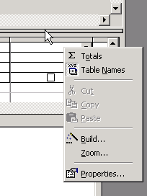
  - >Click on Build. You will see the Expression Builder.
  - 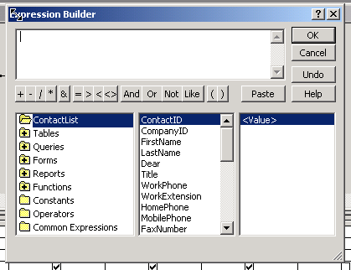
  - Expression Builder provides aids to access data in objects.
  - 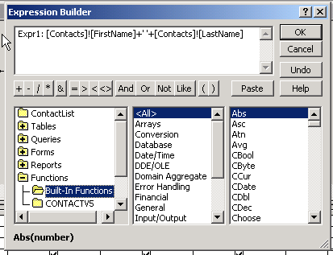
  - The Built-In Functions provides a long list of data manipulation functions that can be used to create data in a column. In the above example I am concatinating two fields to make a full name field called Expr1.
  - See Working With Expressions in the MS Access Help.
  - Common Functions that you may needs
    - + - Concatination (Connect or join) of 2 or more fields with like data types. Cannot concatinate dissimilar data types (eg., Numbers and text cannot be concatinated. Must convert to a common type)
    - Conversion functions, Esp CSTR to convert numbers to strings so that you can concatinate numbers or dates with strings
    - Text Functions to manipulate string data.
      - Instr – Find character pattern in a string
      - Mid – Select characters from the middle of a string. Left and Right select the n characters from the Left or Right of a string.
      - Rtrim, Ltrim, Trim – Trim blanks from a string
    - You may need Domain Aggregate functions to get sums or other group calculations (Dsum, DAve, DMin, etc.)

